Care4Growth

* **Enabling Reuse and Recycle of children’s articles**

**Solution Roadmap**

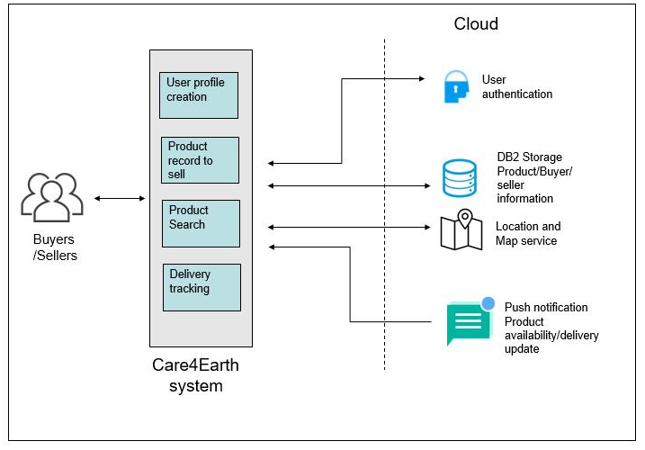

**Product Roadmap with Current Status**

